

BOMB DEFUSAL
MANUAL
Created by Ethan Dunning, Matthew Mahan,
and Zachary Nalepa

Version 0110
Verification Code: 1001

Welcome to the dangerous and challenging world of bomb defusing.
Study this manual carefully; you are the expert. In these pages you will find everything you need to know to defuse even the most insidious of bombs.
And remember — One small oversight and it could all be over!

Defusing Bombs
A bomb will explode when its countdown timer reaches 0:00 or when too many strikes have been recorded. The only way to defuse a bomb is to disarm all of its modules before its countdown timer expires.

[put picture of setup here]

Modules
Each bomb will include up to 6 modules that must be disarmed. Each module is discrete and can be disarmed in any order.
Instructions for disarming modules can be found in the following pages.
Strikes
When the Defuser makes a mistake, the bomb will record a strike which will be displayed on the indicator above the countdown timer. Bombs with a strike indicator will explode upon the third strike. The timer will begin to count down faster after a strike has been recorded.
If no strike indicator is present above the countdown timer, the bomb will explode upon the first strike, leaving no room for error.
Gathering Information
Some disarming instructions will require specific information about the bomb, such as the serial number. This type of information can typically be found on the module’s information tab.

Section 1: Modules
Modules can be identified by Sticky Notes on the GPIO Board.
When the Defuser sees a Sticky Note, They will select the appropriate Module button on the Raspberry Pi screen. They will then need to give you the critical information portrayed on both the screen and the board so you can help them disarm the Module.
All modules must be disarmed to defuse the bomb.

On the Subject of The Button
You might think that a button telling you to press it is pretty straightforward.
That’s the kind of thinking that gets people exploded.
Follow these rules in the order they are listed. Perform the
first action that applies:

- If the button is blue and the button says "Abort", hold the button and refer to "Releasing a Held Button".
- If the button says “Detonate” and the name of the color of the button has more than 4 letters, press and immediately release the button. Otherwise, hold the button and refer to "Releasing a Held Button".
- If the button says “Disarm”, do the opposite of when the button says “Detonate”.
- If the button is gray hold the button and refer to "Releasing a Held Button".
- If the Button is yellow, and you have defused at most 3 modules, press and immediately release the button.
- If the button is red, press and immediately release the button.
- If this is the last un-defused module, press and immediately release the button.
- If none of the above apply, hold the button and refer to "Releasing a Held Button".

Releasing a Held Button
If you start holding the button down, a colored strip will light up on the right side of the module. Based on its color, you must release the button at a specific point in time:
- Yellow strip: release when the countdown timer has a 3 in any position.
- White strip: release when the countdown timer has a 9 in any position.
- Blue strip: release when the countdown timer has a 7 in any position.
- Red strip: release when the countdown timer has a 1 in any position.

a | e | l | A | E | A
n | a | D | o | M | e
R | b | c | J | J | m
N | F | f | . | , | T
. | d | - | f | o | E
C | C | R | S | c | L
b | S | d | M | g | /

On the Subject of Keypads
I'm not sure what these symbols are, but I suspect they have something to do with occult.
- Only one column below has all four of the symbols from the keypad.
- Press the four buttons in the order their symbols appear from top to bottom within that column.

On the Subject of Wires
Oh heavens no, not the green one!

First, the Defuser must input the order of the colored wires from left to right.

After the colors have been input, read through the list of statements below, and pull the wire corresponding to the FIRST statement which has criteria matching the color set.

- IF the last wire is purple and there are no yellow wires, pull the fourth wire.
- IF there is exactly one green wire, and there is more than one blue wire, pull the first wire.
- IF there are no orange wires, pull the second wire.
- IF there are only two different colors of wires in the set, pull the last wire.
- IF there are all different colors of wires in the set, pull the third wire.
- IF the first and last wires are green, and there are no purple wires, pull the second wire.
- OTHERWISE, pull the first wire.

On the Subject of Targeting
What? No, not “what.” WHAT?
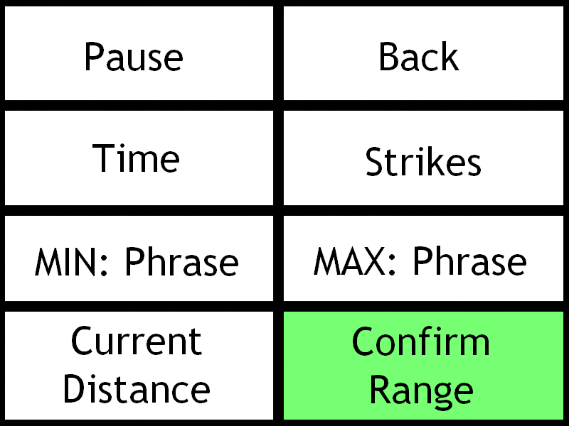
Figure 1: Example Layout of Bomb Screen.
The Defuser must first set the slide on the sensor to the calibrating distance for calibration. The Defuser must then press the calibrate button and wait 3 seconds.

The Defuser will then be prompted to set the slide within the current range and press the confirm range button.

The Defuser will then be presented with a word or phrase corresponding to how the minimum and the maximum of the current range may be calculated. The current minimum may be calculated by adding the increment to the previous minimum. Likewise, the current maximum may be calculated by subtracting the increment from the previous maximum.

The increment can be calculated by referring to the corresponding table for that range. The increment must be calculated independently for the minimum and maximum. Find the word or phrase in the table. The column corresponds to the whole part of the increment and the row corresponds to the decimal part of the increment. The increment is given in centimeters.

The initial range starts at 0 cm to 15 cm.

See next page for range tables.

Range 1:
 | 0.0000 | 1.0000
0.0451 | THEIR | I C
0.3210 | I DON’T KNOW | THEY’RE
0.6124 | WHAT | I SEE

Range 2:
 | 0.0000 | 1.0000 | 2.0000
0.0000 | GO BACK | NOTHING | I GOT IT
0.1372 |  | OUT OF RANGE | READ
0.4444 | RED | UHHH | BLANK

Range 3:
 | 0.0000 | 1.0000 | 2.0000
0.0000 | OK | I GOT A STRIKE | NOPE
0.1082 | ARE YOU SURE | OKAY | UH HUH
0.2169 | LIKE | YOU DONE? | CORRECT
0.3292 | YOU DONE | IT’S BLANK | READY
0.4031 | SLOW DOWN | DON’T TELL ME | IT SAYS

